Primary Five LESSON NOTES | 2018
Victorious Education Services 2015 |  | Term Two

P.5 SCIENCE LESSON NOTES TERM TWO 2015
TOPIC1:
COMPONENTS OF THE ENVIRONMENT “SOIL”

WEEK 1
LESSON 1: SOIL AND ITS TYPES
Soil is the top most layer of the earth surface where plants grow.It is the medium in which plants get water and nutrients.
Terms used in soil
- Soil Erosion: this is the removal of top soil by its agents.
- Soil Profile: it is the vertical arrangement of soil layers.
- Soil Exhaustion: this is the process by which soil loses its fertility.
- Leaching: it is sinking mineral salts (soil nutrients) to the deeper layers where plant roots cannot reach.
- Soil Sampling: it is the taking of samples of soil from different parts of the garden to be analyzed in the laboratory.
- Soil Texture: this is the roughness or smoothness of soil particles.
- Soil Drainage: it is the ability of the soil to allow water to pass through it.
- Soil structure: Is the arrangement of soil particles
- Soil capillarity: Is the upward movement of water through the soil.
- Water retention: Is the ability of soil to retain water

Types of soil
There are three types of soil, namely;
- Loam Soil
- Clay Soil
- Sandy Soil | Sand soil

LESSON 2: PROPERTIES OF SOIL AND IMPORTANCE OF EACH TYPE
LOAM SOIL
Properties of Loam Soil:
• It contains balanced particles of sand and clay.
• It contains good quantity of humus than clay and sand soil.
• It is well aerated than clay and sand soil.
• It contains all soil components in balanced amounts.
• It is dark brown in colour.

CLAY SOIL
Properties of Clay Soil:
- It retains a lot of water than Sand soil and Loam soil.
- It has little humus.
- It has fine particles.
- It is sticky when wet.
- It has the highest level of capillarity
- It is poorly aerated due to the closely packed soil particles.
- It is suitable for pottery i.e. making cups, plates, tea pots, candle wax stands etc…

An experiment to show that Clay soil has the highest level of capillarity.
Procedure:
Fill three long glass tubes (with ends open) with tightly packed sand, clay and loam soils.
Plug the lower ends with some cotton wool.
Stand the tube in about 3cm of water in a trough or basin
Illustration
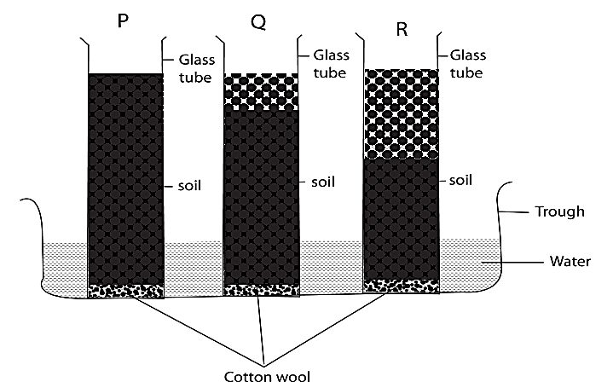
Clay
Loam
Sand

Observation
After a few hours, water is seen risen through soils in each tune.
Water rises to the greatest height in clay soil medium height in loam and to the lowest height in sand soil.
Conclusion:
Clay soil has the greatest rate of capillarity or capillary action than sand or loam soil.

SAND SOIL
Properties of Sandy soil
- It is easily drained, ie. It allows water to go through easily.
- It has poor rate of capillarity due to large air spaces between particles .
- It is well aerated because of large air spaces.
- It dries out quickly.
- It is poor in plant food ie it lacks humus and mineral salts.
Experiment to find out the rate of drainage of water through different soils

Procedure:
- Take three glass funnels, place loose plugs of cotton wool in each of them.
- Half fill the funnels with equal volumes of dry sand, clay and loam soil.
- Stand them in three glass jars.
- Pour equal volume of measured water in each funnel.

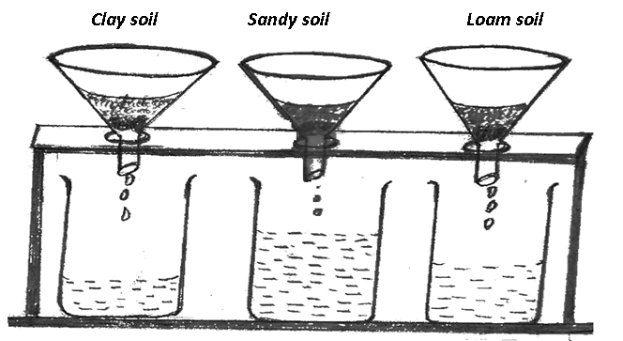

Observation:
After some minutes, more water is collected in the jar containing sand followed by loam and little water in clay.
Conclusion:
Sand soil allows water to pass through it easily.
N OTE :Sand soil has the highest drainage
LESSON 3: FORMATION OF SOIL
Soil is formed by the following ways:
(i) Weathering of rocks: This is the process by which rocks are broken down into small particles to form soil.
Factors that lead to weathering
Temperature: when rocks are heated by the sun, they expand and contract when it is cold and these causes the rocks to crack and break down into small pieces.
Water: running water carries pieces of rocks which keep on knocking each other causing them to break into pieces and form soil.
Action of human and animals
As animals walk on roads, they break down rocks to form small particles which in turn form soil.
Human actions like mining building roads break down rocks into small pieces to form soil.
(ii) Decomposition of matter: This is the rotting or decaying of dead matter to form soil. This helps in the formation of humus
Agents of decomposition
Bacteria
Fungi

LESSON 4: COMPONENTS OF THE SOIL
Soil consists of both living and non-living components;

Living components of soil
- Living organisms such as; bacteria, earthworms.
Importance of living components of soil.
Bacteria and fungi help in decomposition of matter.
Earthworms aerate the soil
Non- living components of soil
- Rock particles
- Air
- Water
- Dissolved mineral salts
- Humus (dead organic matter)
- HUMUS
Experiment to show that soil contains humus
Procedure:
•Take soil sample and put in a glass.
•Pour water and stir
•Leave it to settle.
Illustration

Observation:
After some minutes, soil particles settle and dead organic matter ( humus) floats on the water.
Conclusion: Soil contains humus (dead organic matter)
- AIR
Air is found in spaces between soil particles called pore spaces.
Air is used by organisms to breathe
Experiment to show that soil contains air
Procedure:
Get a lump of soil and lower it into a beaker containing water
Illustration

.
Observation:
Bubbles of air will be seen coming out..
Conclusion: The bubble represent that the air in the soil is escaping hence soil contains air.

- WATER
Water is a component of soil found between particles
Importance of water in the soil.
It dissolves mineral salts in the soil
It is used by plants to make their own food
Experiment to show that soil contains water
Procedure:
Put a lump of soil in a beaker and cover it.
Put the beaker on heat.
Illustration

Observation:
Water droplets will be seen on the side of the beaker.
Conclusion:
Droplets of water represent the water escaping from soil in form of water vapour, so soil contains water.

LESSON 5: GENERAL IMPORTANCE OF SOIL
(i) For growing crops
(ii) It contains nutrients for the growing plants.
(iii) It holds water which supports plant growth.
(iv) It contains air which plants need.
(v) It is used in pottery, i.e making of clay articles.
(vi) Soil contains minerals e.g copper, gold, iron, aluminium etc…
(vii) Soil is used in the construction of roads and houses.
- It is a habitat for animal’s e.g earthworms, termites, crickets, squirrels etc….

WEEK 2:
TOPIC 1: SOIL EROSION
Soil Erosion is the removal of top soil by its agents.

Agents of soil erosion
An agent of soil erosion is the factor that helps soil erosion to take place.
Agents of soil erosion include;
• Animals
• Wind
• Running water.

Types of Soil Erosion
Types of soil erosion include the following:
• Wind erosion (Carrying away of the loose and dusty, light soil particles)
• Rill erosion (Shallow channels are formed by slow moving water)
• Splash erosion(Rain-drop erosion)
• Sheet erosion (occurs when large section of topsoil is uniformly carried away)
• Gully erosion (Deeper depression due to failure to control rill erosion)
• River bank erosion (when a flowing river strikes its banks and carries away the soil)

Causes of Soil Erosion (factors that leave the soil bare exposed to the agents)
•Deforestation: this is the massive cutting down of trees without planting others.
•Over cultivation: it is the growing of crops on the same piece of land every year without leaving it to rest for some time.
•Bush burning: this is the burning of vegetable cover leaving the soil bare.
- Over grazing
- Over stocking of animals
- Monocropping
- Ploughing down hill
ACTIVITY
How do the following practices lead to soil erosion
- Bush burning
- Over grazing
- Deforestation
- Overcultivation
- Monocropping
- Ploughing down hill

Effects of Soil Erosion
• Soil erosion leads to loss of soil fertility.
• It leaves plant roots bare. (Exposes the roots of plants)
• It leads to silting of water bodies which affects the aquatic animals.
• It destroys roads by creating trenches and pot holes
• It leads to breakdown of houses
Siltation is the eroding of materials into water bodies
Effects of siltation
- It causes flooding of the surrounding areas
- It makes the water bodies shallow
- Leads to death of aquatic animals
Soil exhaustion
- This the loss of soil fertility
Causes of soil exhaustion
- Soil erosion
- Leaching
- Over cultivation
- Monocropping

LESSON 2: SOIL CONSERVATION
Soil conservation refers to the keeping of the soil fertile and in one place
Ways of conserving soil
• Controlling soil erosion.
• Avoiding adding dangerous or poisonous substances to the soil.(soil pollution)
- Proper disposal of wastes like polythene papers.

Control of soil erosion
Soil erosion can be controlled through the following ways;
- Contour ploughing
- Strip cropping
- Agro-forestry
- Shifting cultivation
- Controlled grazing on the land
- Afforestation and re-afforestation
- Terracing,
- Mulching
- Inter-cropping
- Crop rotation
- Bush fallowing

- Mulching
Mulching is the covering of soil with dry plant materials. The main purpose of mulching is to keep moisture in the soil and control soil erosion.
Examples of materials used in mulching
• Dry grass
• Dry banana leaves
• Coffee husks
• Maize straw
• Sorghum straw
• Wood shavings.

Advantages of Mulching
• It controls soil erosion
• Mulches decay and form humus
• It controls weed growth
• It moderates soil temperature
• It increases water infiltration in the soil.
- Keeps moisture in the soil

Disadvantages of Mulching
• Mulches can be fire hazards.
• It may hide pests
• It is tiresome and expensive.
• Mulches may be a source of seeds of weeds.

- Crop Rotation
This is the growing of different crops on the same piece of land seasonally.

Illustration
1st season Beans Maize Cabbage
2nd season Cabbage Beans Maize
3rd season Maize cabbage Beans

Advantages of crop rotation
• Breaks down life cycle of pests.
• Legumes add nutrients to soil.
• Parasitic weeds are controlled
• Maintains soil fertility.
• Controls soil erosion.
• Improves crop yields.

- Cover cropping
This is the growing of crops which cover the soil, such crops are called cover crops.
Examples: Pumpkin, Peas, Tomatoes, Groundnuts etc

Soil fertility:
This is ability of soil to support proper plant growth
LESSON 3: WAYS OF IMPROVING SOIL FERTILITY
Soil is said to be fertile when it contains enough water, air, humus and nutrients
Ways of maintaining soil fertility include;
- Practicing crop rotation
- Leaving the soil to rest through bush fallowing.
- Practicing mulching
- Using fertilizers.

FERTILIZERS
These are chemical substances added into the soil to improve its fertility
There are two groups of fertilizers namely;
(a) Natural fertilizers
(b) Artificial fertilizers.

- Natural fertilizers
These are organic fertilizers\ manure which are made from decayed plant and animal remains.
They include;
(i) Green manure: This is got from decayed green plants which are buried in soil.
(ii) Farm yard manure. This is got from urine and dropping from animals.
- Compost manure: This is got from decayed house hold refuse like left over foods, rubbish and others
Advantages of Natural fertilizers
•They improve soil texture.
•They improve water retention in the soil.
•They release nutrients slowly.
•They stay longer in the soil
•They are cheap to make

Disadvantages of natural fertilizers
•They smell badly.
•They are tiresome to make
•Plant and animal matter may not be easily obtained.
They are bulky

b) Artificial fertilizers
These are fertilizers which are made in factories.
Examples:
- Nitrogenous fertilizer contains nitrates.
- Phosphorous fertilizer contain phosphates
- Potash fertilizers contains potassium
Compound fertilizers contain more than one mineral e.g. diamoniumphosphate, NPK, SSP and Urea.

Advantages of Artificial fertilizers
• They are quick in improving soil fertility.
• They contain the right nutrients in the correct quantity.
• They provide the needed mineral salts without fail.
• They provide freedom of choice to farmers as they buy the type that they need.
• They improve on crop yields.

Disadvantages of Artificial fertilizers
• Frequent use of artificial fertilizers destroys the soil structure and texture.
• Too much use causes an imbalance in mineral salts in the soil.
• Fertilizers pollute the soil after they have been used for a long time.
• They kill some useful living organisms in the soil.
• They are expensive.
• They may be washed into rivers and springs causing water pollution.

Compost Manure
This is a mixture of rotten organic matter that can be made from household refuse, weeds, plant remains and animal wastes.

How to make compost manure
• Mix domestic garbage like animal waste, plant remains like banana peels, dry grass, maize stalks, leaves and other forms of plant material.
• Put the organic matter either in a heap or a pit to allow it decay.
• Turn the material over regularly to make sure that the bacteria causing decaying are uniformly distributed through it. (using a garden fork)

LESSON 4: HARMFUL MATERIALS ON THE SOIL AND THEIR EFECTS
Harmful materials on soil are those things that pollute the soil or degrade land.
Land Degradation is the spoiling or reducing of the value and fertility of the land.

Examples of harmful materials
• Farm chemicals e.g. artificial fertilizers.
• Industrial wastes
• Plastics, polythene papers, broken glass and tins.

Effects of harmful materials on soil
•Use of artificial fertilizers for long period of time lowers the soil’s capacity to generate fertility.
•Insecticides, pesticides and weed killers kill some of the living organisms in the soil.
•Industrial wastes make the land barren
•Plastics, polythene, broken glasses and tins do not allow plant roots to enter the soil.
Plastics, polythenes and broken glasses prevent water from entering the soil

LESSON 5: TOPICAL TEST
Topic 2:
HEAT ENERGY
WEEK 3:
LESSON 1: MATTER
Matter is anything that occupies space and has weight. Mass is the quantity of matter a body/ object contains while weight is the amount of gravitational force exerted on mass of an object.
Matter made up of small particles called molecules. The smallest invisible particles of matter are also known as atoms.
Examples of matter
Wood, metal, soil, air paper, pen pencils, smoke, oil steam etc…
Properties of matter
- Matter occupies space (like in gases, solids and liquids)
- Matter has weight
- Matter exerts pressure

LESSON 2: STATES OF MATTER
STATES OF MATTER
Matter exists in three states namely:
Solids
Liquids
Gases
Arrangement of molecules in different states of matter
O O O
O
O O
ooooooooooooooooooooooooooooooooooooooooooooooooSooooooooooooooooooooooooo
O o oo o o
O o oo o o

Qn. Mention any four examples of each of the following states of matter
i) Solid state ii) Liquid state iii) Gases

Characteristics of different states of matter
- SOLIDS
They have molecules which are closely held together
They have a definite shape
They can change into other forms when heat
Some solids expand when heated
Solids have great cohesion force between molecules
Cohesion force
This is the force of attraction between molecules of the same substance.
- LIQUID
Liquid have molecules that are spaced.
They have weak cohesion force that is why molecules in liquid expand more about freely
Liquids expand more when heated
Liquids change into solid by freezing
Some liquids change into gases by heating
They do not have a definite shape. They the shape of the container.

- GASES
Molecules in gases are far a part
Most gases cannot be seen but can be felt.
Gases expand the most when heated
Gases have neither definite shapes nor volumes

N.B
Adhesion is force of attraction between molecules of different substances.

LESSON 3 & 4: MIXTURE
MIXTURE: A Mixture is a combination of two or more substances or elements
Types of mixtures
- Solution mixtures
- Suspension mixtures
- Emulsion mixtures
Methods of separation of mixtures
i) Physical sorting. This is a method of separating solid and solid mixture using hands eg. removing stones from rice or seed.
ii) Fractional distillation method: This is a method of separating liquids that vaporize at different temperatures.
- Filtration methods: filtration is the removal of insoluble particles from liquids. Example removal of seeds from juice, removal of solid particles from water etc
NB: The remaining insoluble particles of the filter are known as residues.
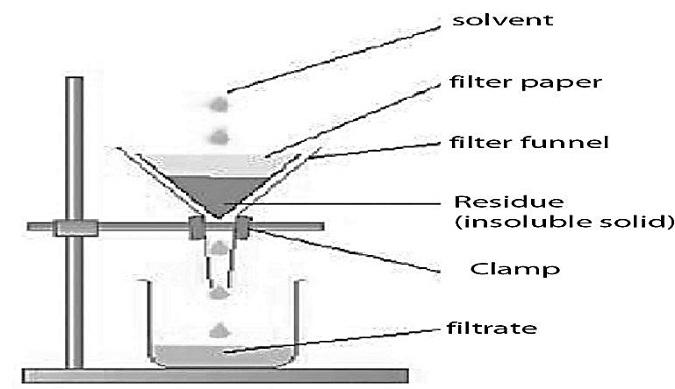

- Decanting method: in this method, a mixture of solid and liquids is poured into a container and left to stand for some time letting the solid particles to settle at the base of the container. A clear liquid above is poured off slowly into another clean container.
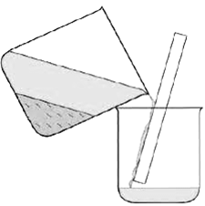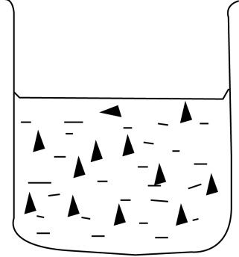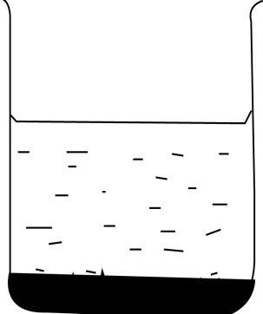
1 2 3

Mixture of liquid & liquid solids settle at the bottom clear liquid is poured off

- Evaporation to dryness: Evaporation can help to separate salt from sand: it is the common method used in extraction of salt from salty water with sand/ soil particles.

Steps followed to separate a mixture of sand and salt
1. Get a mixture of salt and sand and put it in a container and pour water in it.
2. Stir to make salt dissolve in water.Sand will not dissolve because it is insoluble.
3. Filter off the sand to obtain a salty solution filtrate.
4. Boil the solution to dryness. Evaporation will make the water dry and leave salt solidified at the bottom of the container(saucepan)

- Using paper chromatography: this is a method of separating mixture of different colour pigments into separate components using paper chromatography.
- Using a separating funnel eg a mixture of water and kerosene
- Winnowing eg in cereals
- Using magnets, this is done when one material is magnetic and the other one is non magnetic.
- Floatation

SOLUTES, SOLVENTS AND SOLUTION
- Solute: is a substance that can dissolve in a solvent.
Example of solutes; Salt, Glucose, Sugar, powdered milk etc
b) Solvent:is a substance that can dissolve a solute.
Example of solvents;Water, alcohol, Kerosene, petrol, acetone (nail paint remover), turpentine (dissolves oil paints), perfumes, dry cleaning fluid, etc…
NB: Water is a universal solvent because it can dissolve almost all solutes.
- Solution:Is a uniform mixture of a solvent and a solute.

Example of solutions
Salt and water, sugar and water, iodine and alcohol, salty solution, sugary solution

Types of solutions
a) Saturated solution: Is a solution that cannot dissolve any more solute at that temperature.
b) Diluted solution: It is a solution that contains smaller quantities of solute compared to what it can dissolve at certain temperature even if it is stirred.
c) Super saturated solution: This is a type of solution which can not dissolve any more solute even after heating.

LESSON 5: ENERGY
Energy is the ability to do work. Energy is measured in Joule (j)
Types of energy
There are two types of energy namely.
- Potential energy b) Kinetic energy

POTENTIAL ENERGY
It is the type of energy possessed by objects at rest.
Or It is the type of energy possessed by the body due to relative parts of its position.
Examples: A stone at rest, car parked, and book placed on table
KINETIC ENERGY
It is the type of energy possessed by objects in motion (moving objects) e.g a stone thrown in air, leaf falling on the ground, a person running.

Using pendullum bob or a stone swinging in air.
A Possesses potential energy
B Possesses kinetic energy
C Possesses potential energy

c
A
B

Forms of Energy
Sound energy- Electric energy
Light energy-Chemical energy (No details should be given here)
Heat energy-solar energy

WEEK 4
LESSON 1: HEAT ENERGY
Heat is s form of energy that causes temperature of a body/ matter to increase OR it is a form of energy that causes matter to become hot or warm.
Sources of heat energy
• A source of heat is anything that can produce/ provide heat.

• The sun (the main source of heat energy in the environment)
• Friction/when objects rub against each other.
• Food
• Decaying matter
• Fuel from burning objects e.g firewood, charcoal, candle

Uses of heat energy
• For cooking food
• For drying food
• For drying clothes
• For warming things
• It helps in rain formation
• Helps animals to feel warm
• Heat is used in killing germs
• People use heat to roast food
• Heat from the sun provides warmth for seed germination

LESSON 2: EFFECTS OF HEAT ON MATTER
- Heat causes temperature of matter to increase.
- Heat causes some solids to become liquids and liquids to gases
Heat can cause some objects to expand
Expansion is the increase in size of an object. Most object increase in size when heated.
Contraction is the reduction/ decrease in size of an object
- Expansion and contraction of matter
- Liquid, gases and solids expand and contract at different rates.
- Gases expand fastest, followed by liquids and solids expand least
- Gases expand greatest because their molecules are further apart and free to move.
Experiments to show expansion in different states of matter
- Expansion in solids

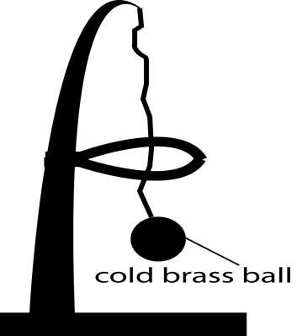 | 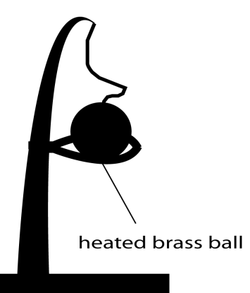
Before heating | After heating
When the brass ball is cold, it passes through the ring. But when it is heated, it does not pass through because it expands and becomes bigger.
- Bimetallic strip: It contains metals of different expansion rates.
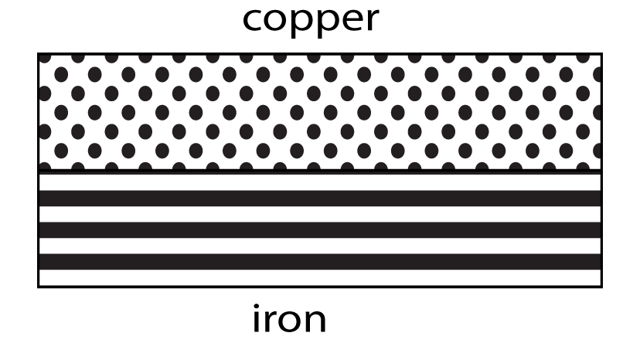 | 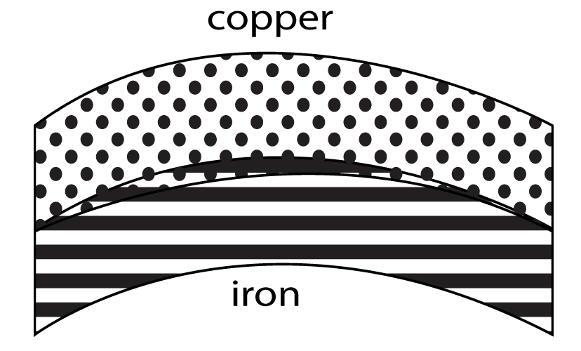
Before heating | After heating
When heated, copper expands faster than iron so it will bend over iron with low expansion rate.
Application of Bimetallic strip – electric flat iron, car indicators, Air conditioners, Fridges, Cookers/Ovens
- Expansion in liquids
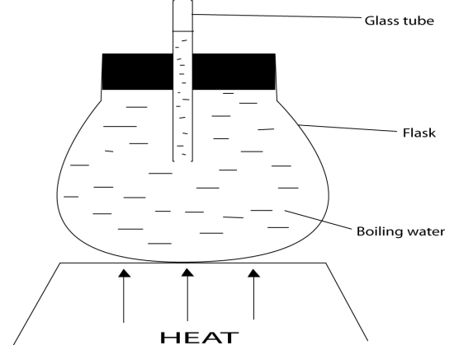
On heating the water, you will realize that water moves/raises to a certain level through the glass tube as shown below:
- Expansion in gases
When the water in the pan heats the air inside the bottle, it will expand hence making the balloon on the bottle to expand as shown below:

Effects of expansion and contraction
- Weakens some objects
- Makes objects break
- Loss of shape to some objects
- Causes cracks on some objects
Prevention of bad effects of expansion and contraction
- Gaps should be left between railway lines to leave room for expansion on hot weather

b) Electric wires and Telephone wire are loosely fixed on poles to leave/give room for contraction on cold weather.

b). Gaps should be left on soda battles to allow expansion of liquids inside when frozen

LESSON 4: CHANGE OF STATE OF MATTER
Matter can change from one state to another due to changes in temperature. The energy responsible for changes in state of matter is heat.
3

4
3
1
2
LIQUIDS
GASES
SOLID
5
6
1. Melting
2. Evaporation
3. Sublimation
4. Deposition
5. Freezing
6. Condensation

a) Melting: Is the process by which solids changes into liquids (e.g. ice into water)
b) Evaporation: Is the process by which liquids change into gases. This is also called vaporization (i.e. Water changing into steam on heating)
c) Condensation: Is the process by which gases change into liquids (e.g. Steam into water).
d) Freezing: Is the process by which liquids changes into solids (e.g. water into ice)
e) Sublimation: Is the change of state from solids to gases.
f) Depositon: is the process by which gases change into solids.

LESSON 5: HEAT TRANSFER (how heat travels)
Conductors and insulators of heat
Conductors, are materials which can allow heat to pass through easily
Examples of conductors
- Silver 4.lead
- Copper 5.Iron
- Aluminium 6.steel
Insulators, are materials which do not allow heat to pass through them.
Examples of insulators
- Plastics 4. Paper
- Rubbers 5. cloth
- Dry wood 6.wool
Methods of heat transfer
- Conduction
- b) Convection
- c)Radiation
- Conduction: This is the process by which heat passes (travels) through solids.
In solids heat is transferred from one heated molecules to another until the whole solid object is heated.

Wax piece labeled A will melt fastest, followed by B and C will melt last. Wax will melt because of conduction of heat across the metal(iron rod)

- Convection: This is the process by which heat travel through liquids and gases. It travels inform of convectional currents.
The particles in liquids and gases are heated and become lighter and move upwards while the cooler and heavier particles move downwards.
Experiment to show convection in liquids
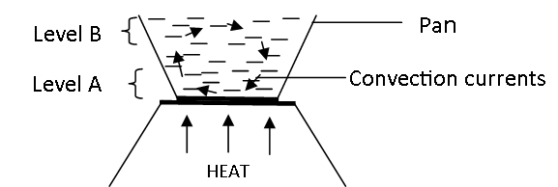

Particles nearest to the source of heat are heated and become light and move upwards while the cooler/ heavier particles move downwards forming convectional currents.

- Radiation: This is the process by which heat travels through a vacuum or space. A vacuum is an area/place without matter. When heat travels by radiation, it does not need any medium of transmission.
Examples of radiation in nature
- Heat from the sun reaches us by radiation
- When one sits near a fire place; (charcoal stove, cooker, ironing clothes) he/she receives heat by radiation.

WEEK 5
LESSON 1&2: IMPORTANCE OF HEAT TRANSFER
Importance of conduction
- It helps us to cook
- Enables us to roast meat
- Conduction of heat enables us to iron clothes.

Importance of convection
- Smoke is driven out of the kitchen through the chimneys by means of convection
- A charcoal stove, flat iron and a lantern lamp continue burning by convectional currents
- It enables us to get fresh air in our houses
- Water in a kettle on fire boils by convection.
- Convection helps to drive away bad smell through the vent pipe of a VIP latrine.
- Helps in the formation of rainfall.

Importance of radiation
- Radiant heat from the sun helps to dry our clothes and seeds.
- Heat from the fire reaches our bodies by radiation.
- Radiant heat from the sun helps in rain formation.

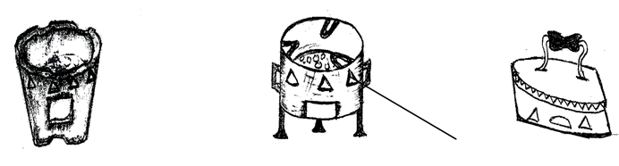

Metallic & clay charcoal stoves | Ironing box | Ventilation
Lantern | Boiling water

Explanation
Metallic charcoal stove
- The hole marked with letter P let in fresh air (oxygen) to supports burning.
- Hole marked R lets out warm air. They are always on top/ above the fire because once air is heated, it becomes light and goes up.

Qn. Why do people prefer using clay charcoal stoves to metallic stoves?
- Clay preserves heat for a longer time than metals
- Clay stoves do not rust and can last longer than metallic stoves
- Clay stoves save charcoal compared to metallic stoves.

Qn. Why are handles of ironing boxes made out of wood?
Made out of wood to prevent the user’s hands from being burnt by heat since wood is a poor conductor of heat.

THE VACUUM FLASK/ THERMOS FLASK
It is called a vacuum flask because it has a vacuum. A vacuum flask keeps hot things hot and cold thing cold because it prevents heat loss or gain by convection, conduction or radiation.
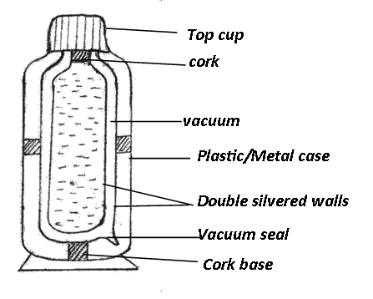
The structure of a vacuum flask

Functions of the parts
- Cork: it prevents heat loss or gain by conduction.
- Vacuum: it prevents heat loss or gain by conduction or convection
- Double silvered surface: reflect heat into the flask preventing heat loss or gain by radiation.
- Metal case: it protects the inner parts from damage.
- Vacuum seal: It is where the vacuum was sealed from during manufacture
- Cup: used to take the fluid stored in the flask.

Qn.Why are vacuum flasks not commonly used in rural areas?
- Vacuum flasks are expensive to buy.
- They are delicate (can break easily)

LESSON 3: HEAT AND TEMPERATURE
Heat is s form of energy that causes temperature of a body/ matter to increase.
Temperature:Temperature is the degree of hotness or coldness of an object or place.It is measured by an instrument called a thermometer which gives the units in degrees.

Thermometer scales
There are two types of thermometer scale that are commonly used in measuring temperature.
- Celsius scale / centigrade scale
- Fahrenheit scale
Celsius/Centigrade Scale
On Celsius scale, there are 100 degrees running from 0⁰-100⁰C. 0⁰C representing the freezing point of water and 100⁰, the boiling point of water.
NB:The word centigrade means “consisting of or dividing into 100 degrees. Centigrade scale was invented by a Swedish Astronner Anders Celsius.

Fahrenheit Scale
This scale was invented by Daniel Gabriel Fahrenheit in 1714 a German physicist.
The scale is divided into 180degrees. 32⁰F is the freezing point of water and 212⁰F is the boiling point.

LESSON 1: CONVERSION OF TEMPERATURE FROM ONE SCALE TO ANOTHER
Fahrenheit to Celsius scale (⁰C = $5/9$ (⁰F -32⁰)
Celsius scale to Fahrenheit ⁰F = $9/5$⁰C + 32⁰

Examples
ºC = ⁵/₉(F.32
⁵/₉(68 – 32)
⁵/₉x 36
5 x 4 = 20
68ºF
- Convert 68⁰F to centigrade scale
⁰C = $\frac{180 }{9}$
ºC = 20⁰
$∴$ 68$℉$ = 20$℃$

0
⁰C = $5/9$ (F-32⁰)
$5/9$(68⁰ – 32)
${ 5}/9$ X 36
$$\frac{5 X 36}{9}$$

oF = 9c/5 + 32
(9/5 x 80) + 32
(9 x 16) + 32
144 + 32
144
+32
176
80ºC = 176ºF
- Change 80⁰C to ⁰F
144⁰ +32⁰
= 176$℉$
$∴$80$℃$ = 176 ⁰F

⁰F = (${ 9}/5X$⁰C) + 32
= (${ 9}/5$ x 80) + 32
= (9 x 80) + 32⁰
⁵
144⁰ + 32⁰
Activity: a) Convert to Centigrade scale: i) 77⁰F ii) 212⁰F
b) Change the following to ⁰F: i) 10⁰C ii) 80⁰C iii) 40⁰C
LESSON 2:TOPICAL TEST

LESSON 4: TYPES OF THERMOMETER
- Clinical thermometer
- The six’s maximum and minimum thermometer
- The wall thermometer
- The ordinary Scientific thermometer

- Clinical thermometer
- This is a thermometer used to measure the temperature of human body. Its scale starts from 34⁰C and ends 42⁰C.
- Its scale begins from 34⁰C and ends at 42⁰C because human body temperature does not fall below 34⁰C and does not go beyond 42⁰C.
- The normal human body temperature is 37⁰C or 98.4⁰F
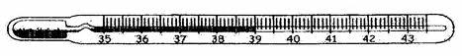

Bulb kink/constriction bore glass stem

Functions of the parts
Bulb: stores mercury.
Kink: it prevents the back flow of mercury to the bulb before the health worker takes the reading.

Qn. Why should a thermometer be placed in the armpit, mouth or arms when taking temperature of a person?
Such places have ability to cover the whole bulb hence enabling the doctor to take correct reading.
Cover the whole bulb to allow uniform expansion of mercury.
NOTE: A health work shakes the thermometer before using it on another person to allow mercury go back to the bulb.

- The six’s (maximum and minimum) thermometer
- This is the type of the thermometer used to measure the highest and lowest temperatures of the day.Highest is measured during the day while lowest temperature is measured during night time.
- It was invented by James six towards the end of the 18th century.
- It is used by some farmers and at weather station.
The structure of the six’s minimum and maximum thermometer
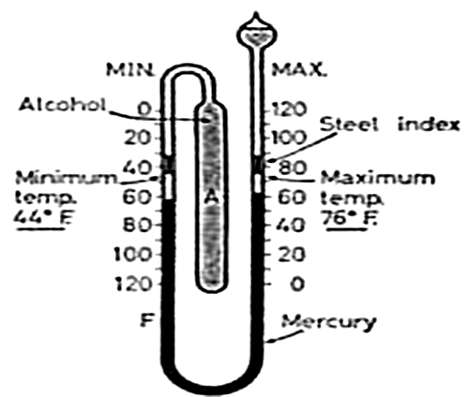

How it works
- It uses both alcohol and mercury ,
- It has two small steel indices that have light springs to hold them in position in the narrow tube.
- The expansion and contraction of liquid in the bulb causes movement of the mercury thread. The mercury level in one arm of the thermometer rises. The steel indices provided with light springs to hold them in position in the stem.
- Expansion and contraction of the fluid in the large bulb causes movement of the mercury threat, one or other index is pushed forward by the mercury and left in the extreme position reached. Thus the lower end of the index on the left indicates the minimum and that on the right the maximum temperature attained.

Wall thermometer
This is the type of thermometer which is used measure room temperature.
It is hanged in a house or office.
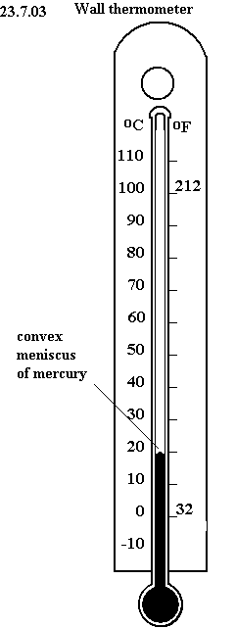
The structure of a wall thermometer

- It measures temperature of air.
- Its scale ends at 60⁰C because room temperature will never rise beyond 60⁰C.

LESSON 5: THERMOMETRIC LIQUIDS
There are two liquids used in thermometer namely;
- Mercury ii) Alcohol

Qn. Why is mercury used in thermometer?
- Mercury is easily seen
- Mercury does not stick on the walls of the glass
- Mercury is a good conductor of heat.
- It has an even and regular expansion.

Advantages of using alcohol over mercury
- It expands more than mercury.
- It has a low boiling point (of +78⁰C) compared to mercury.
- It is suitable for low temperature.
- It is in expensive
- It is not harmful to the environment
- It does not solidify easily.

Reasons why water is not used in thermometers
- It is colourless so it is not easily seen
- It sticks on the walls of the glass
- It is a bad /poor conductor of heat
- It needs a lot of heat to expand
- It evaporates
- Its expansion is not uniform.

LESSON 2:TOPICAL TEST
TOPIC 3
OCCUPATIONS IN OUR COMMUNITY: GROWING CROPS

LESSON 3:CLASSIFICATION OF TUBER CROPS
Tuber Crops:
Tuber crops are crops that store their food in either the stem or the roots.
Tuber crops are classified into:
- Root tubers
- Stem tubers.
Root tubers:
These are plant that store food in their swollen underground roots
Examples:
- Sweet potatoes
- Carrots
- Cassava
- Turnips
- Beetroots

Stem tubers:
These are plants that store food in their swollen underground stems
Examples:
- Irish potatoes
- White yams.

LESSON 4: GROWING AND CARING FOR TUBER CROPS
(Propagation of tuber crops)
Propagation of tuber crops
- The term propagation refers to the way how plants are grown.
- Tuber crops are propagated through the following ways.
- Sweet potatoes are propagated by use of vines or runner stems.
- Carrots are grown from seeds. The seeds are planted by broad casting in prepared nursery beds and later transplanted to the main garden.
- Cassava is grown from stem cuttings.
- Turnips are grown from seeds which are first planted on the nursery bed and later transplanted to the main garden.

Caring for tuber crops
Tuber crops are cared for in the following ways;
Weeding
Pruning
Thinning
Spraying
Fencing

LESSON 5: COMMON PESTS AND DISEASES FOR TUBER CROPS
Crop pests are organisms that destroy our crops. They may be insects, animals or birds.
The pests of roots crops mainly attack roots and leaves.
Common pests of tuber crops include:
- Eelworms
- Moles and rates.
- Squirrels.
- Caterpillars
- Sweet potato weevil.

Eelworms: These attack the roots of certain crops e.g sweet potatoes and carrots.
Rats, Mole rats and Squirrels These feed on roots of crops such as cassava and sweet potatoes.
Caterpillars: These destroy sweet potato leaves and cassava leaves. This is the larva stage of butterfly.
Sweet potato weevils: This burrows into the roots and vines of the plant. It causes the taste of the roofs to change from sweet to bitter.

Other tuber crops pests include;

Army worms
Moths
Locusts
Aphids
Monkeys
Wild pigs

The common diseases of root crops include;
- Cassava Mosaic
- Potato blight
- Wilt diseas

Cassava Mosaic
It is caused by a virus spread by a white fly and it causes poor growth in cassava.
It causes leaves to shrivel and fail to open and turns yellowish.

Potato Blight
It affects the leaves and stems of \sweet potatoes.
Dark brown patches caused by bacteria appear on the leaves.
Since the disease removes the chlorophyll, it hinders the plants ability to make food.

Characteristics of common tuber crop pests.
Common tuber crop pests have the following characteristics;
• Some have strong claws for digging into the ground.
• They have prominent incisors for cutting the tuber crops.
• They mainly feed on tubers.
• Some stay in tunnels.

WEEK 7
LESSON1: EFFECTS OF PESTS AND DISEASES ON TUBER CROPS
The pests and diseases affect the tuber crops in the following ways;
• The stems and leaves lose chlorophyll.
• The growth of crops slows down due to the unhealthy state of the plants.
• The root tubers get damaged i.e. rotting of tubers, holes on tubers.
• Yellowing of leaves.
• Curling of leaves.
• Lowers the quality of the tuber crops.
• The tuber crops lose taste.

LESSON 2: CONTROLLING PESTS AND DISEASES OF TUBER CROPS
Pests and disease of tuber crops can be controlled through the following ways;
•Uprooting and burning unaffected plants.
•Spraying and dusting the crops with pesticides.
•Timely weeding.
•Practicing crop rotation.
•Using traps to control moles, rats and squirrels.
- Early planting
- Physical guarding
LESSON 3: HARVESTING, PROCESSING AND STORAGE OF TUBER CROPS
Tuber crops are harvested using the following ways:
- Digging them out of the ground using a stick or a hoe
- Uprooting them using the hands

Processing of tuber crops
Tuber crops can be processed by peeling, sun drying, and some can be ground into flour e.g cassava and dried sweet potatoes.

Storage of tuber crops
Dry tuber crops can be stored for future use. This can be done by
• Storing in a granary
• Storing in silos.
• Refrigerating ( e.g. carrots)

Importance of storing tuber crops
• Prevent wastage.
• Get what to eat in future.
• To keep some for planting in the next seasons.
• To have constant supply of food to eat.

Farm Records
Farm records are written information showing different out puts and inputs on a farm.

Examples of farm records
These include;
• Type of seeds or other planting materials used.
• When crops were planted and harvested.
• Whether the crops were attacked by diseases and pests.
• The control measure used.
• Quantity harvested per acre.
• Amount of money spent on inputs and amount generated.

Importance of farm records
• Records help the farmer to;
• Know whether the farm is making profits or losses.
• Identity areas of development and investment.
• Budget for the farm.
• Know about the weaknesses that might be affecting the running of the farm.

LESSON 4: SCIENCE ORIENTED CLUBS IN SCHOOLS
Aims of Science clubs in schools
- To make science lessons interesting to the learners.
- To enable pupils understand how scientists work
- To enable pupils acquire knowledge about things they will do in their future life to support themselves.
- To promote the learning of science

Examples of Science Oriented Clubs
- Young farmers’ clubs
- Science and technology clubs
- Wildlife clubs

Young farmers clubs
These are clubs composed of young boys and girls in and out of the school who are interested in farming

Aims of young farmers clubs
- Teach school children how to grow and care for crops.
- Grow crops and sell them to get money.
- Keeping and using farm records.
- Develops interest in young peoples to take up farming as their job
- Teach young people better methods of farming
- Enabling young people grow more food crops in homes.

LESSON 5: TOPICAL TEST

TOPIC 4
BACTERIA AND FUNGI
WEEK 8
LESSON 1: BACTERIA
Bacteria are single celled organisms that reproduce by means of binary fission.
Some bacteria are harmful (cause diseases) while some are useful in nature.

Places where bacteria re found.
Pit latrines Dust bins, Contaminated water
Rubbish pits Decaying matter Bodies of animals
In soil In air
Reproduction of a Bacterium
- Bacteria reproduce by the process of Binary Fission/ Cell division.
- Binary fission is when the bacterium divides into two bacterial cells that are genetically identical.
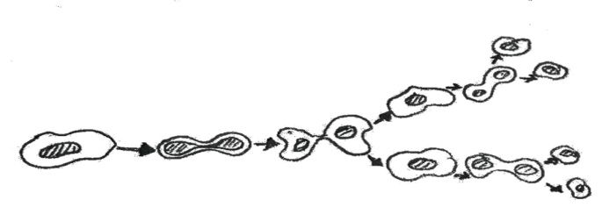
Reproduction of bacteria

- Some bacteria need oxygen to respire and are called aerobic bacteria.
- Some do not need oxygen to respire and many of them cause disease.
- These are called anaerobic bacteria.
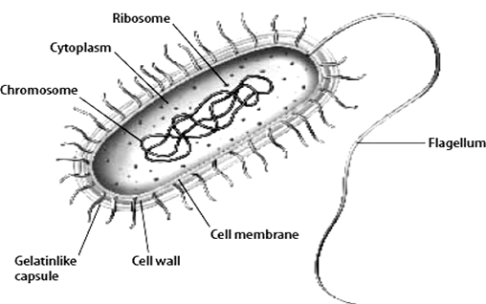
The structure of a bacterium

Nucleus: controls activities of the cell.
Cilia: used for movement while other use the flagellum.
Cytoplasm: liquid matter in the cell.
Vacuole: sac for waste materials/ food.
Cell wall: holds the nucleus, cytoplasm, and vacuole and allows food and air into the cell.
It also allows the cell to excrete waste.

Characteristics of bacteria
- Bacteria are single celled ( have one cell)
- They reproduce by binary fission
- Bacteria are microscopic organisms.
- Bacteria respire.

LESSON 2: NATURE OF BACTERIA
TYPES OF BACTERIA
Bacteria are of two types.
- Harmful bacteria
- Useful bacteria/ harmless bacteria

- Harmful bacteria
These are bacteria responsible for causing diseases and make food to go bad and are grouped according to their microscopic structures of their shapes.
- Spherical bacteria: they are spherical in shape and responsible for causing pneumonia, sore throat, boils etc…

Examples of Spherical bacteria
Staphylococcus  ( boils, blood poisoning) | Streptococcus  (cause sore throat, scarlet fever) | Diplococcus  cause pneumonia)

- Rod-shaped bacteria. These are also called bacilli. They are cylindrical in shape.
Example - Mycobacterium that cause tuberculosis, Salmonella tophi that causes typhoid. They are also responsible for causing diseases like; anthrax caused by bacillus anthrasis

- Spirilla and Spirochaete: The spirilla bacteria do not move while the sporochaete move.
Example. – Treponema causes syphilis, Vibrio cholera causes cholera

Viruses are also pathogenic but they are much smaller than bacteria
They do not reproduce on their own; they need some host in order to reproduce. This makes them slower and moves awkward at reproduction.

QN. Why are viruses not classified as living organisms?
- They cannot reproduce on their own; they need a host cell in order to reproduce.
- They are not cells but particles
- They do not have nucleus, cytoplasm, or cell membranes which are common in cells of living organisms.
- They are smallest than bacteria and can only be seen by use of electro – microscope.

27
- Useful bacteria
These are bacteria that are useful in our daily lives.
- Help in breaking of volumes of faeces in latrines, septic tanks and sewerage systems.
- They are used in making of vitamin B₁₂
- Some are used in making of yoghurt by fermenting milk and clotting milk.
- Some are found in root nodules on roots of legumes. Help in improving soil fertility.

LESSON 3: PREVENTION, CONTROL, TREATMENT AND PREVENTION OF BACTERIAL DISEASES
Prevention and control of bacterial diseases
- Treatment using antibiotics and antiseptics.
- Sterilizing medical equipment
- Re-heating or re-boiling left over or cold food before eating.
NOTE:
Antibiotics are chemical substances which kill bacteria without causing harm to human bodily cells. E.g they come in form of capsules, tablets, syrups or injections.
Disinfectants: these are chemical substances used to kill germs on the surface.
Antiseptics are chemical substances used to kill germs in wounds or sewerage systems.
Sterilization is the method of killing germs on medical instruments using heat or chemical.

LESSON 4: FUNGI
Fungi are a group of living organisms which feed on dead decaying matter. Such organisms are known as saprophytes.
- They grow in moistened places.
- Their bodies are made up of branched threads called hyphae.
- The hyphae make their bodies called Mycelium.
- Most fungi reproduce by means of spores.
- They feed saprophytically.

Examples of Fungi
Mushrooms Yeast
Toad stools Moulds (penicillium&Mucor)
Puff balls Mildew

LESSON 5: USEFUL AND HARMFUL FUNGI
Useful fungi (mushrooms, penicillium moulds)
- Some are eaten by man as food e.g mushrooms
- Yeast gives flavour to cheese.
- Yeast is used in baking bread.
- Yeast is a good source of vitamin B₁
- Penicillium moulds are used to make anti biotic called penicillin.
- Yeast is also used in fermentation of alcohol.
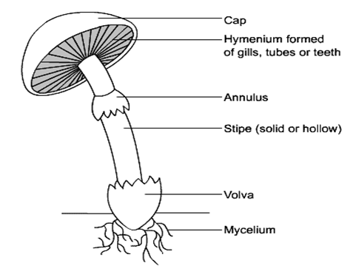
Gills

Or Ring

Hyphae

Functions of the parts
Cap: holds and protects the gills
Gills: they produce and store spores.
Ring: holds the cap when a mushroom is still young.
Stipe stalk: it holds the cap in upright position.
Hyphae: it helps in absorbing food from decaying matter in the soil.

N.B. mushrooms cannot make their own food because they have no chlorophyll. They feed saprophytically

HARMFUL FUNGI (toadstools, moulds, mildews)
- Some fungi are poisonous when eaten e.g toadstools.
- Some cause diseases like ringworm, athletes’ foot and candida.
- They also cause disease in plants e.g. potato blight, maize rust, tomato blight, trice blast.
- Some fungi make food to go bad e.g.moulds grow on food.

Qn. How do the following fungi reproduce?
- Yeast by budding.
- Moulds by spores.
- Toad stools by spores.
^{WEEK 9}
LESSON 1& 2: PREVENTION AND CONTROL OF DISEASES CAUSED BY FUNGI
Ways of controlling fungal diseases
- Ironing clothes.
- Cook food before eating.
- Sterilize all medical instruments/equipment.
- Maintain good hygiene and sanitation in order to keep germs away.
- Using fungicides to kill fungi.
- Use essential drugs used to treat fungal diseases.

Similarities between bacteria and fungi
- Both can be useful and harmful
- Both cause diseases which are curable
- Both can make food to go bad (food poisoning)

Differences between bacteria and fungi
FUNGI BACTERIA
Reproduce by means of spore -Reproduce by binary fission
They are big -They are single celled
Fungal diseases are not immunized -They are immunisable.
Diseases are spread through body contact -Bacterial disease spread through air, water and vectors.

LESSON 3: TOPICAL TEST

